Class 5 – User Guide

Introduction

The Class 5 app is a course recommendation system aiming to make Princeton students* more aware of courses they might enjoy based on their interests. Based on the user’s own preferences, combined with the preferences of other students with similar interests or academic paths, each user receives a curated selection of suggested courses that match their preferences. A user starts by logging in through CAS and entering their information to create a new user profile. The user can then access the Dashboard page, which displays a curated list of suggested courses. On the Dashboard, users can view and dislike suggestions, search any course, switch filters to reveal the most Liked or Disliked courses

*In the pilot version of the application, only users with Princeton netids can access the system. Thus, we are assuming that our users are Princeton undergraduates.

----------------------------------------------------------------------------------------------------------------------------

**Use Cases:**

----------------------------------------------------------------------------------------------------------------------------

Accessing Class 5

Class 5 is a web application hosted in the cloud. The site can be accessed using any search engine or browser* at [class-5.herokuapp.com](https://class-5.herokuapp.com), which takes you to the Home page. From the Home page, you will be able to access the rest of the application.

**\*Note:** For the best user experience, we suggest that you access Class 5 on Safari (for Mac users) or Google Chrome (which you can download at <https://www.google.com/chrome/?brand=YTUH&gclid=Cj0KCQiA5bz-BRD-ARIsABjT4nibAKgA1I04RxhOaRkIbw19LfW9-qrn8dFRdpNhgxJeZgtwzVO8r5oaAsnTEALw_wcB&gclsrc=aw.ds>)

----------------------------------------------------------------------------------------------------------------------------

Logging into Class 5

**Logging In**

If you have not yet logged in through CAS authentication on our website, or if your session has expired, a “LOGIN” button will display on the top right corner of the Home page on the right side of the blue navigation bar. Click on this “LOGIN” button to be taken to the CAS authentication screen. Enter NetID *yournetid* and password *yourpass*, and click “LOGIN.” NetID *yournetid* must be the OIT NetID that identifies a person to a computer system or electronic service at Princeton. To find your NetID *yournetid,* you can search by query at <https://www.princeton.edu/search/people-advanced>. The password *yourpass* must be the password associated with your OIT Princeton account.

Note: the “LOGIN” button, and the “DASHBOARD” button both require a user to login using DUO Authentication. So if a user is not already logged in through CAS authentication on our website, clicking on the “DASHBOARD” button located in the blue navigation bar functions the same way as clicking on the “LOGIN” button (i.e. a user has to login to proceed and will be redirected to either the page titled “Profile” or the page titled “Dashboard” *see below for details).



**Proceeding from the Homepage if already Logged in**

If you have already logged in through CAS authentication on our website and your session cookies have not expired, the navigation bar will contain buttons entitled “PROFILE” and “DASHBOARD”, among some others.

If you click on the button titled “DASHBOARD”, if you are a new user (i.e. a user who has not filled every required field in the page titled “Profile”), you’ll be redirected to the page titled “Profile”. If you are a returning user (i.e. a user who has already completed a user profile), you’ll be directed to the page titled “Dashboard”.

If you click on the button titled “PROFILE”, you will be redirected to the page titled “Profile”.



**DUO Authentication**

If you are directed to the DUO Authentication page (i.e. have provided the correct NetID and password associated to your OIT Princeton account),* provide a secondary form of identification. You can click on the button “Send Me a Push”, “Call Me”, or “Enter a Passcode”. “Send Me a Push" will take you to the trusted device that was set during DUO Authentication, and you can click on the confirmation button. “Call Me" will call the trusted device that was set during DUO Authentication, and you can follow the instructions provided by DUO Authentication. “Enter a Passcode" will text a list of codes to the trusted device that was set during DUO Authentication, and you can follow the instructions provided by DUO Authentication. If DUO Authentication was successful (i.e. you have authenticated the login attempt by following the instructions provided by Duo Authentication), the page entitled “Login” will redirect you to another page (details below).

**Redirection after Duo Authentication**

If you are a new user (i.e. a user who has not filled every required field in the page titled “Profile”), you’ll be redirected to the page titled “Profile”. If you are a returning user (i.e. a user who has already completed a user profile), you’ll be redirected to the page titled “Dashboard”.

*As a corollary to our assumption above, we are assuming that our users have already set up DUO Authentication and are users in the Princeton University Active Directory (i.e. that the user has an active OIT NetID).

Note: for all of the login features listed above to work to the full extent, we assume that the user has cookies enabled. The application will still work, however, some features, like remembering if you have logged in recently, may not work.

----------------------------------------------------------------------------------------------------------------------------

Logging out of Class 5

If you have already logged in through CAS authentication on our website and your session cookies have not expired, the navigation bar will contain a button entitled “LOGOUT”. Clicking on the button entitled “LOGOUT” will log you out of Class 5 using DUO Authentication, and it will also wipe your session cookies.



----------------------------------------------------------------------------------------------------------------------------

**PROFILE**

Accessing your profile

**New User**

After logging into Class 5 (see “Logging into Class 5”), you will be automatically redirected to the Profile page.

**Existing User**

After logging into Class 5 (see above section “Logging into Class 5”), click on “PROFILE” in the top navigation bar if you are not currently on the Profile page (note: if you have not entered all required information, you will be automatically redirected to the Profile page when you click ‘LOGIN’ or ‘DASHBOARD').



Creating your profile (new user)

**Profile Page Element Glossary**

“x” (Remove) button → 

“+” (Add) button → 

“Save Changes” button → 

Navigation bar → 

There are four sections that the user must fill out before being able to proceed to the page titled “Dashboard”.

The four sections are titled “Personal Info”, “Courses You Like,” “Courses You Dislike,” and “Favorite ‘Fifth’ Course”, and they can be filled out in any order. Upon first entry (i.e. you have never pressed the “Save Changes” button with any fields filled), the Profile page will display your name (the name that is in Princeton’s database), and empty fields that must be filled. The fields that must be filled are within the red outlined boxes below.



**Populating Personal Info:**

In the bubble with the heading “Personal Info”, enter your name *Firstname Lastname* (note: this field will be pre-populated with the name associated with your OIT NetID) into the field titled “Full Name”, graduation year *xxxx* into the field titled “Graduation Year”*,* and (intended) major *major_name* into the field titled “Intended Major”. Note: “Full Name”, “Graduation Year”, and “Intended Major” are all required fields, and if you do not fill them out, you *will not* be able to proceed to the Dashboard page.

*Adding Certificates:*

To add an (intended) certificate, click the “+” button below “Intended Certificates” to create a new input box, and enter the certificate *certificate_name*. You may continue adding certificates using the “+” button up until the maximum of 6 certificates.

Note: “Intended Certificates” are not required fields, and you *will* be able to proceed to the dashboard if you choose not to fill them out.

*Removing Certificates:*

To remove the certificate *certificate_name*, click the “x” on the right side of its input box. You may remove certificates using the button until there are none left.

**Note**: For all of the *“Populating Courses”* headings, when we refer to “Suggestions You Dislike”, we assume you have disliked some of the suggestions given in the dashboard page. However, on the first entry, “Suggestions You Dislike” will have no fields, so you will only interact with this section when you wish to *update* suggestions.

On first entry, “Suggestions You Dislike” is empty:



After disliking suggestions (details in the “DASHBOARD” section of this document”), “Suggestions You Dislike” has fields:



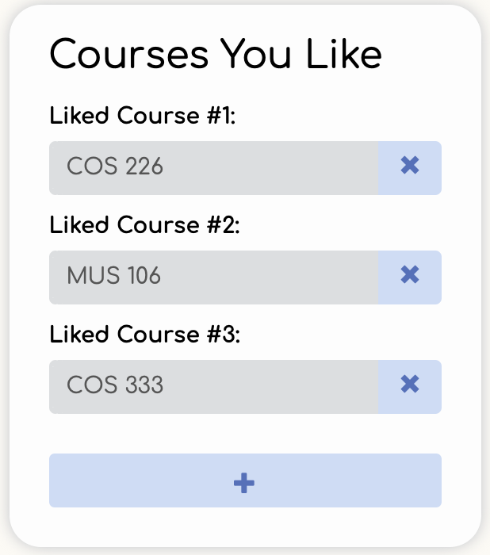

**Populating Courses You Like:**

Under “Courses You Like” enter the department and number *DEP XXX* for 2-6 courses at Princeton you have liked.

These courses may not overlap with your Disliked courses. **Note:** if you make the error described in the previous sentence, the fields you entered in both “Courses You Like” and “Courses You Disliked” will not be saved.

These courses may not overlap with your Disliked Suggestions. **Note:** if you make the error described in the previous sentence, the fields you entered in “Courses You Like” will not be saved.

These courses must also be distinct (i.e. you cannot enter ‘COS 226’, for example, multiple times), and also the courses must be valid *DEP XXX* combinations offered at Princeton (i.e. you cannot enter ‘COS 226sdsasf’, for example). If you make the errors described in the previous sentence, we will not save the fields you entered in “Courses You Like” will not be saved.

**Note:** you must fill *at least* two fields under “Courses You Like”. If you do not fill them out, you *will not* be able to proceed to the Dashboard page. Likewise, you cannot delete liked courses when there are only 2 displayed - details below.

*Adding a Liked course:*

To enter a 3rd Liked course (past the minimum 2 required), click the “+” button below the bottommost “Liked Course” input box to create a new input box, and enter the department and number *DEP XXX* of another course you have enjoyed. You may continue adding Liked courses using the “+” button up until the maximum of 6 Liked courses.



*Removing a Liked course:*

For the Liked course *DEP XXX*, Click the “x” button on the right side of its input box. You may remove Liked courses using the “x” button until you reach the minimum of 2 total Liked courses.

**Populating Courses You Dislike**

(Follow the exact same procedures as “Courses You Like” to populate “Courses You Dislike.”)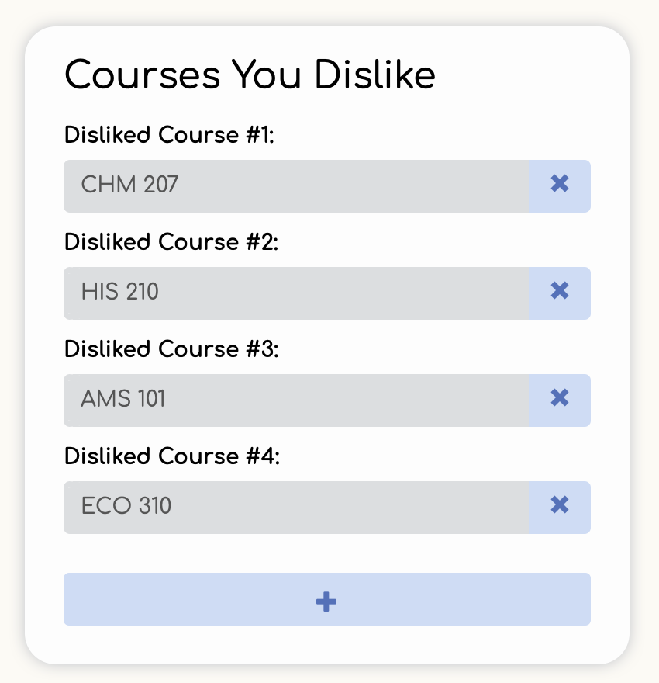

Under “Courses You Dislike” enter the department and number *DEP XXX* for 2-6 courses at Princeton you have disliked.

These courses may not overlap with your Liked courses. **Note:** if you make the error described in the previous sentence, the fields that you entered in both “Courses You Like” and "Courses You Dislike" will not be saved.

These courses may not overlap with your Favorite course. **Note:** if you make the error described in the previous sentence, the fields you entered in both "Courses You Dislike" and “Favorite Fifth Course” will not be saved.

These courses must also be distinct (i.e. you cannot enter ‘COS 226’, for example, multiple times), and also the courses must be valid DEP XXX combinations offered at Princeton (i.e. you cannot enter ‘COS 226sdsasf’, for example). If you make the errors described in the previous sentence, we will not save the fields that you entered in "Courses You Dislike".

**Note:** you must fill *at least* two fields under "Courses You Dislike". If you do not fill them out, you *will not* be able to proceed to the Dashboard page. Likewise, you cannot delete disliked courses when there are only 2 displayed - details below.



*Adding a Disliked course:*

To enter a 3rd Disliked course (past the minimum 2 required), click the “+” button below the bottommost “Disliked Course” input box to create a new input box, and enter the department and number *DEP XXX* of another course you have disliked. You may continue adding Disliked courses using the “+” button up until the maximum of 6 total Liked courses.

**Note:** A Disliked course can be a course that you have either taken to completion, or dropped after trying it out.



*Removing a Disliked course:*

For the Disliked course *DEP XXX*, Click the “x” button on the right side of its input box. You may remove Disliked courses using the “x” button until you reach the minimum of 2 total Disliked courses.

**Populating Favorite “Fifth” Course:**

Under “Favorite ‘Fifth’ Course” enter the department and number *DEP XXX* for 1 course you consider to be your favorite “5th class”. This could be a course you have found easy, fun, or enjoyed in some way (perhaps unexpectedly!).

**Note:** This 5th course *can* be one of your Liked courses, but *not* one of your Disliked courses. If it is one of your Disliked courses, the fields you entered in "Courses You Dislike" and “Favorite ‘Fifth’ Course” will not be saved. Additionally, this 5th course cannot be one of your Disliked suggestions. If you make this error, your “Favorite ‘Fifth’ Course” will not be saved. 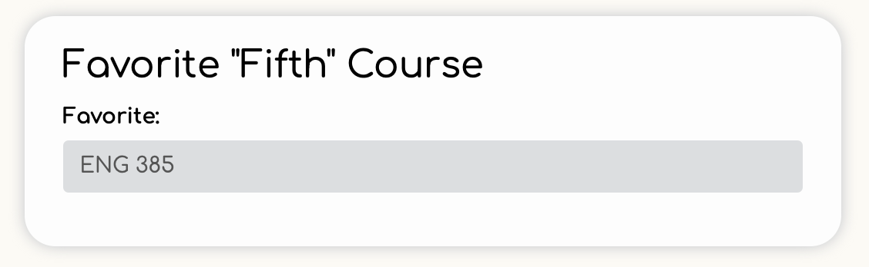

**Saving Changes**

After having inputted the minimum required information to create a user profile – full name, graduation year, intended major, ≥2 liked courses (all courses distinct), ≥2 disliked courses (all courses distinct), and a favorite “5th” course (not a disliked course) – click the orange “Save Changes” button at the bottom of the screen to save your newly-created profile in the system. You are now ready to enter the Dashboard page and view your suggestions.

----------------------------------------------------------------------------------------------------------------------------

Editing your profile (existing user)

After logging into Class 5 (see above), click on “PROFILE” in the top navigation bar if you are not currently on the Profile page. The four sections – “Personal Info”, “Courses You Like,” “Courses You Dislike,” and “Favorite ‘Fifth’ Course” – can be edited in any order.

**Editing Personal Info:**

Under “Personal Info”, enter an edited Full Name *Newfirst Newlast*, Graduation Year *yyyy*, or Intended major *new_major_name* to change your preferred name, graduation year, or major in the system.

**Editing Courses You Like:**

Under “Courses You Like”, edit the input field for the Liked course *OLD XXX* and enter a new Liked course *NEW XXX* to change it.

*Adding a Liked course:*

*See above section “Populating Courses You Like: *Adding a Liked course*”

*Removing a Liked course:*

*See above section “Populating Courses You Like: *Removing a Liked course*”

**Editing Courses You Dislike**

Under “Courses You Dislike”, edit the input field for the Disliked course *OLD XXX*, and enter a new Disliked course *NEW XXX* to change it.

*Adding a Disliked course:*

*See above “Populating Courses You Dislike: *Adding a Disliked course*”

*Removing a Disliked course:*

*See above “Populating Courses You Dislike: *Removing a Disliked course*”

**Editing Favorite “Fifth” Course:**

Under “Favorite ‘Fifth’ Course” edit the input field for the Favorite 5th course *OLD XXX*,

and enter a new Favorite 5th course *NEW XXX* to change it.

**Editing Suggestions You Dislike:**

Under “Suggestions You Dislike,” remove any or all Suggestions You Dislike.

*Remove a disliked suggestion:*

For the disliked suggestion *DEP XXX*, click the “x”

button on the right side of its text

box. You may remove disliked suggestions until there are none left.

*Clear all disliked suggestions:*

Click the button “Clear all disliked suggestions” beneath the header “Suggestions You Dislike” to instantly clear all your disliked suggestions.

After making any edits, click the orange “Save Changes” button at the bottom center of the screen to save your new changes in the system.

**Note:** Any changes listed above will not be saved unless “Save Changes” is clicked.

----------------------------------------------------------------------------------------------------------------------------

Profile Troubleshooting:

**Leaving before saving:**

Change any of the inputs in the input boxes under “Personal Info”, “Courses You Like”, “Courses You Dislike”, or “Favorite ‘Fifth’ Course”, or remove any certificate, Liked course, Disliked courses, or Disliked suggestion. Click the “HOME”, “DASHBOARD”, “ABOUT” (under “INFO”) or “FAQ” (under “INFO”) buttons on the navigation bar, and this warning message will appear.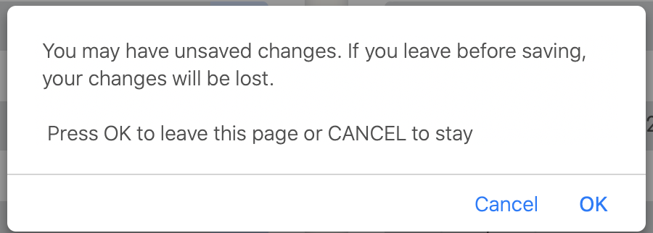

Click “Cancel”, and you’ll remain on the Profile page with your changes intact. Now, click the “HOME”, “DASHBOARD”, “ABOUT” (under “INFO”) or “FAQ” (under “INFO”) buttons on the navigation bar, and this warning message will once again appear. Click “OK” to leave the page without saving your changes. Click “PROFILE” in the navigation bar to return to the Profile page, and your Profile information will be in its previous saved state before any of the most recent changes were made.

Change any of the inputs in the input boxes under “Personal Info”, “Courses You Like”, “Courses You Dislike”, or “Favorite ‘Fifth’ Course”, or remove any certificate, Liked course, Disliked courses, or Disliked suggestion. Attempt to refresh the page or close the tab, and a browser warning will appear. The image shows a safari browser warning prompting you to stay on the page.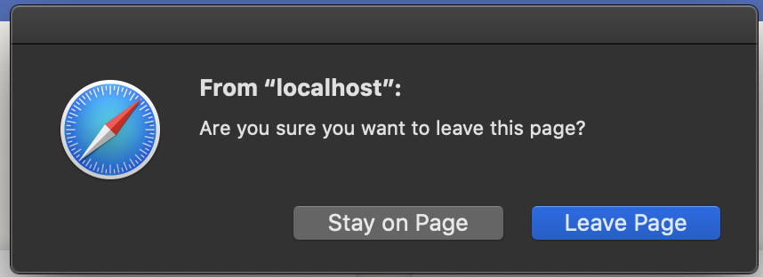

----------------------------------------------------------------------------------------------------------------------------

**DASHBOARD**

Accessing the dashboard

**Dashboard Page Element Glossary**

“Search” button → 

“>” (Change filter) button → 

**New User**

After logging into Class 5 (see “Logging into Class 5”), and creating your profile (see “Creating your profile (new user)”), click on “DASHBOARD” in the top navigation bar if you are not currently on the Dashboard page.

**Existing User**

When you log into Class 5 (see “Logging into Class 5”), you will be automatically redirected to the Dashboard page. If you are already logged in and not currently on the Dashboard page, click on “DASHBOARD” in the top navigation bar to access the Dashboard.

Getting suggestions:

Upon arriving at the Dashboard page (see “Accessing the dashboard”), you will be presented with three sections “Filters”, Suggestions” and “Course Info”. The “Suggestions” section will already be populated with 10 ranked suggestions, curated based on the preferences in your profile.



Refreshing suggestions:

Navigate to the Dashboard page (see “Accessing the dashboard”). For the suggested course *SUG XXX*, click the “x” button on the right side of its text box to immediately add the course to your list of Disliked suggestions, remove it from your list of Suggestions, and get a fresh suggestion. All other suggested courses below the removed suggestion *SUG XXX* will move up one position in rank, and a new suggestion will fill in the “Course #10” position.



From a single load of the Dashboard page, you can use the “x” button to obtain up to 30 fresh suggested courses (in addition to the 10 initially provided). After getting 30 fresh suggestions, you may continue *removing* suggestions by clicking the “x” button, but no new suggestion will appear at the bottom of the list. So, you may remove these last 10 suggestions until there are none left.

Switching Filters:

Upon loading the Dashboard page (see “Accessing the dashboard”), the section to the right of “Filters” will be called Suggestions, and display a list of 10 suggested courses by default.

**Getting top Fifth courses:**

Navigate to the Dashboard page (see “Accessing the dashboard”). Click on *either* the button labeled “Top Fifth Courses” or the “>” button to its right, and a list of the top 50 courses will display in the middle section of the page, in the place of Suggestions (or the previously selected filter). Under the heading “Top Fifth Courses”, click on the text box of the course *DEP XXX* to display its information in the "Course Info" panel. **Note**: if there are fewer than 50 “Fifth” courses preferred by users, then the <50 existing “Fifth” courses will populate this list.



**Getting most-liked courses:**

Navigate to the Dashboard page (see “Accessing the dashboard”). Click on *either* the button labeled “Most Liked Courses” or the “>” button to its right, and a list of the top 50 courses will display in the middle section of the page, in the place of Top Fifth Courses (or the previously selected filter). Under the heading “Most Liked Courses”, click on the text box of the course *DEP XXX* to display its information in the "Course Info" panel.



**Getting most-disliked courses:**

Navigate to the Dashboard page (see “Accessing the dashboard”). Click on *either* the button labeled “Most Disliked Courses”” or the “>” button to its right, and a list of the top 50 courses will display in the middle section of the page, in the place of Suggestions (or whichever filtered list was previously selected). Under the heading “Most Disliked Courses”, click on the text box of the course *DEP XXX* to display its information in the "Course Info" panel.



Viewing course information:

Upon arriving at the Dashboard page (see “Accessing the dashboard”), the "Course Info" panel will be populated with the course information of your top-ranked suggestion. Click on the text box for a different suggested course *DIF XXX* to display its information in the "Course Info" panel. Within any filtered list (see “Switching Filters”), click the text box of any course *ANY XXX* to display its information in the "Course Info" panel.



**Search for any course:**

Within the “Filters” section, in the input box under the heading “Search”, enter the department and number *DEP XXX* of any course whose information you would like to view. Click on the “Search” button to the right of the input box, to display the course information for *DEP XXX* in the "Course Info" panel. Alternatively, click on the autocompleted entry for *DEP XXX* in the autocomplete dropdown to display its course information.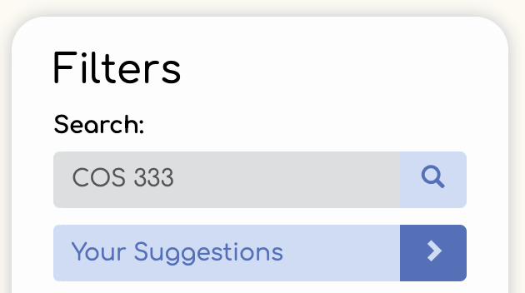

**Navigating course information:**

Search *DEP XXX* in the search bar (see “Search for any course”). Within the “Course Info” panel, you will see the following information for *DEP XXX*:

* Department and number: *DEP XXX*
* Title: *Title Of Course*
* A percentage bar of Likes vs. Dislikes for *DEP XXX*, with annotated “Likes” and “Dislikes” icons along the top
* Favorite Fifth <3: The number of users who prefer *DEP XXX* as their favorite “5th” course. **Note:** this statistic only displays if at least 1 user has indicated *DEP XXX* as their favorite “5th” course.
* Last Offered: The term *Season yyyy* during which *DEP XXX* was last offered
* Description: The course’s official description from the Registrar’s Office
* Professor: The name of the professor *Firstname Lastname* who teaches the course, or a list of professors who teach the course
* Users Also Liked: A list of courses that users who liked *DEP XXX* have also liked. **Note:** if *DEP XXX* is not liked by any user, then the “Users Also Liked” section will not appear.



*Accessing princetoncoures.com info*

For *COS 333* (see “Search for any course”) under the header “External links”, click “Princeton Courses”. You will be redirected to princetoncourses.com with an entered search query for *COS 333*. On the bottom left of the page below the heading “Search Results”, you will get a list of courses matching the query *COS 333.* Click on any of these entries to view its princetoncourses.com information.



*Accessing Registrar’s Office info*

For *COS 333* (see “Search for any course”), under the header “External links”, click “Registrar”. You will be redirected to the Office of the Registar’s website displaying the official course details for *COS 333*.

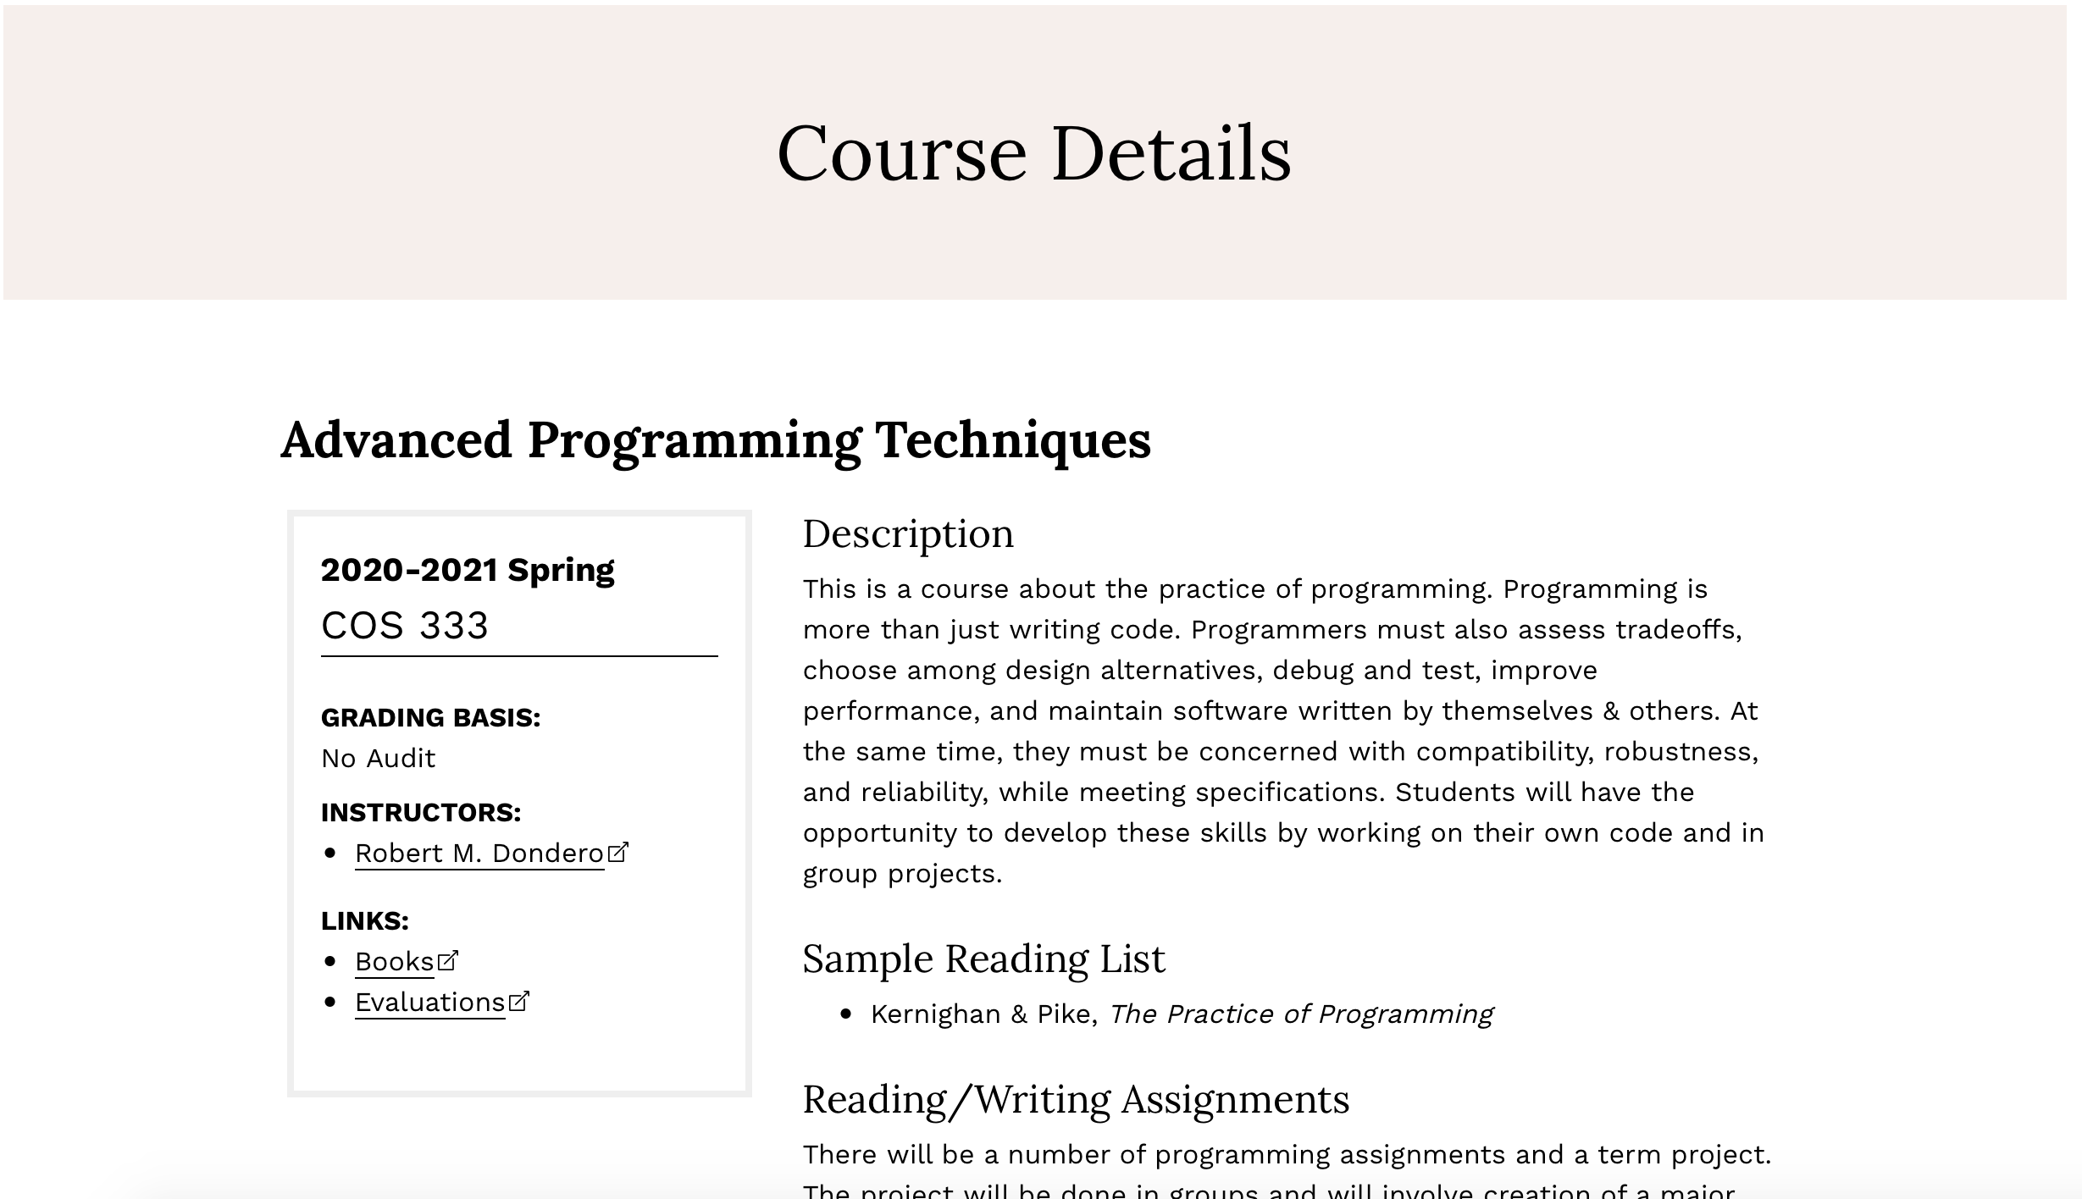

*Accessing Registrar's Office course evaluations*

For *COS 333* (see “Search for any course”), under the header “External

links”, click “Evaluations”. You will be redirected to the Office of the Registar’s Evaluations site, displaying course rating statistics for previous terms, and student course evaluations for *COS 333*. **Note:** if you are logged out of CAS, you will be prompted to log in again (see “Logging in” and “DUO Authentication”).

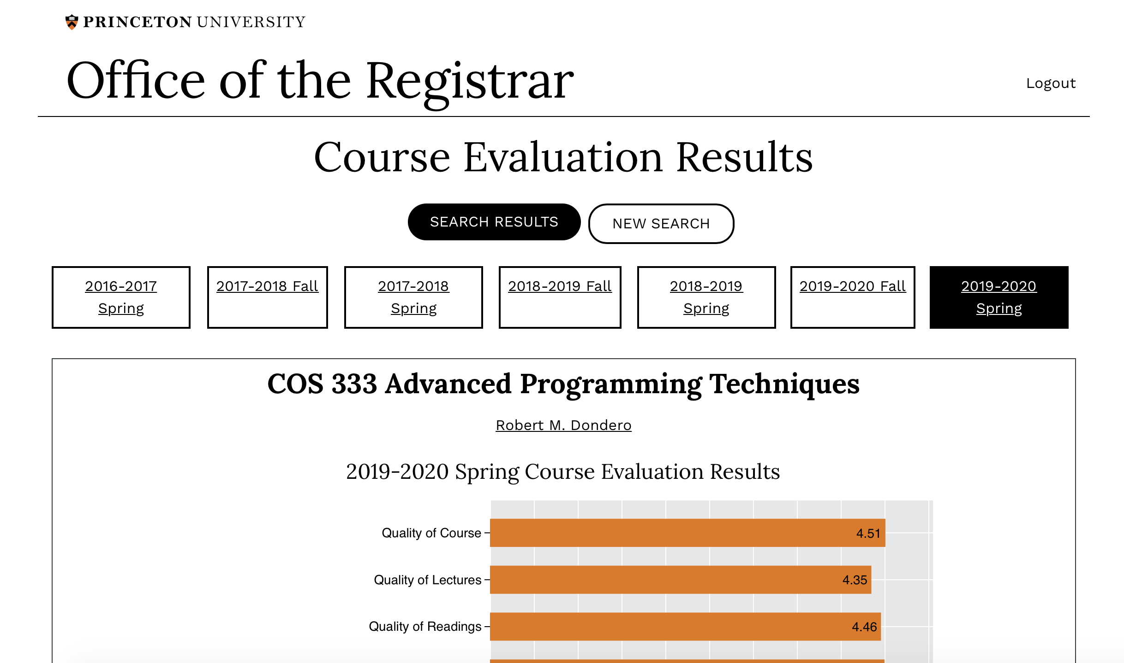

*Find courses similar users like*

For *COS 333* (see “Search for any course”), look under the header “Users Also Liked”

to see courses that users who liked *COS 333* have also liked. Click *COS 226* to display its information in the “Course Info” panel.

*Accessing professor info:*

For COS 333 (see “Search for any course”) under the header “Professor”, click *Robert*

*M. Dondero*. You will be redirected to princetoncourses.com with an entered search query for *Robert M. Dondero*. On the bottom left of the page below the heading “Search Results”, you will get a list of names matching this query. Click *Robert M. Dondero Jr.* to reveal a drop down menu of other courses he has taught, and click any of these entries to view its princetoncourses.com information.

----------------------------------------------------------------------------------------------------------------------------

Using the App on Mobile Phone

Class 5 is additionally a mobile web application. The app maintains full functionality when used on a mobile phone, and all of the use cases above apply. If you are using a mobile device, you can access the application using any search engine or browser at [class-5.herokuapp.com](https://class-5.herokuapp.com), which takes you to the Home page. From the Home page, you will be able to access the rest of the application.

**\*Note:** For the best user experience, we suggest that you use Safari (for iPhone users) or Google’s native mobile browser (for Android users).

----------------------------------------------------------------------------------------------------------------------------

Additional Functionality

**Autocomplete**

In the input boxes for Graduation Year, Intended Major, Intended Certificates, Liked Courses, Disliked Courses, and Favorite “Fifth” Course on the Profile page, and the Search box on the Dashboard page, Class 5’s autocomplete guides the user’s input. As you enter an input, a dropdown list appears with the closest valid entries. Click any of these entries *completed_entry* to fill the rest of the entry.